BBH Mergers Detection Range Description - Bassel Heiba

Being the center of plenty of research for more than a century, LIGO’s detection of gravitational waves marked the beginning of a new era and has opened plenty of doors for new physics. In this project, we delve into the world of gravitational waves and aim to calculate the detection range of gravitational waves produced by BBH mergers. This is achieved by executing a python script in a Jupyter notebook and using the LIGO event data and files provided by the LOSC for both the Hanford, Washington (H1) and Livingston, Louisiana (L1) detectors. Calculating and plotting the detection ranges in Mpcs over a range of total masses between 20-1200 M☉ for BBH mergers shows an intriguing poisson-like distribution.

The Jupyter notebook outlines the signal processing tasks that lead to computing the detection range for BBH mergers. The detection range is the range at which a detector can detect a signal with a signal-to-noise ratio of at least 8 averaged of source orientation and direction. In the tasks, we use the event data hdf5 files of 32s sampled at 4096 Hz for both detectors and the waveform template hdf5 files of 32s sampled at 4096 Hz for both cross and plus polarizations. Finally, we use a parameter json file that contains all the required information about the events and additionally import “[readligo.py](https://losc.ligo.org/s/sample_code/readligo.py)", a python script that allows us to read LOSC data files.

We begin the notebook by setting up the libraries, packages, imports, functions and recalling the data that we are going to need to execute our tasks. One of the packages we import is the PyCBC package which is made specifically for gravitational waves analysis and signal processing. Afterwards, the user is askedFigure 1
 to choose which event we are going to use so the notebook can recall the relevant files. Errors would be generated if the json file under the name “BBH_events_v3.json” was nowhere to be found or if the desired event wasn’t in the json file.

The best way to understand and visualize the signals and data is through plots and figures and so we start by previewing ‘H-H1_LOSC_4_V2-1126259446-32.gwf’ as shown in figure 1. To clean up the data, we get rid of low frequency content as it is mostly distorted with noise. Next, we read, extract and print the parameters for the desired event from H1 and L1 data files. We print some of the data’s properties such as min, max, mean and length of the time and strain values as well as how much of this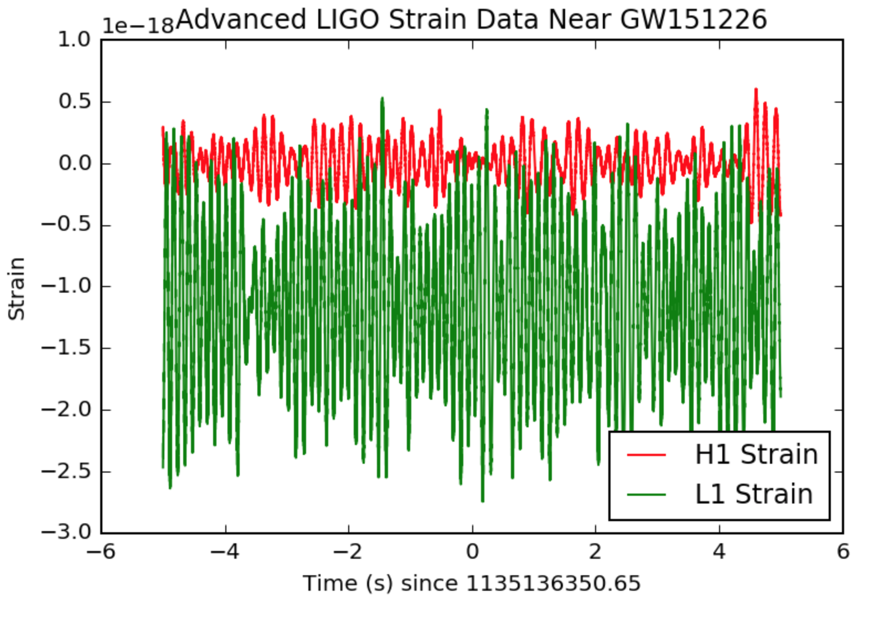 data is usable. One assumption we made here is that the both H1 and L1 have the same time vector and time sample interval so we only call the properties of the time values once.

Figure 1: Hanford Data Preview - Strain vs Time

To get a clearer view of things, we plot the data and focus our plot on the seconds around the event and plot, as shown in figure 2 and print the GPS time of the event. Plotting both the H1 and L1 data together gives you an idea of how the data can be perceived differently on each detector and which detector gives us a clearer indication of a signal. This might be due plenty of factors concerning the sensitivity of the detectors at the time of the events.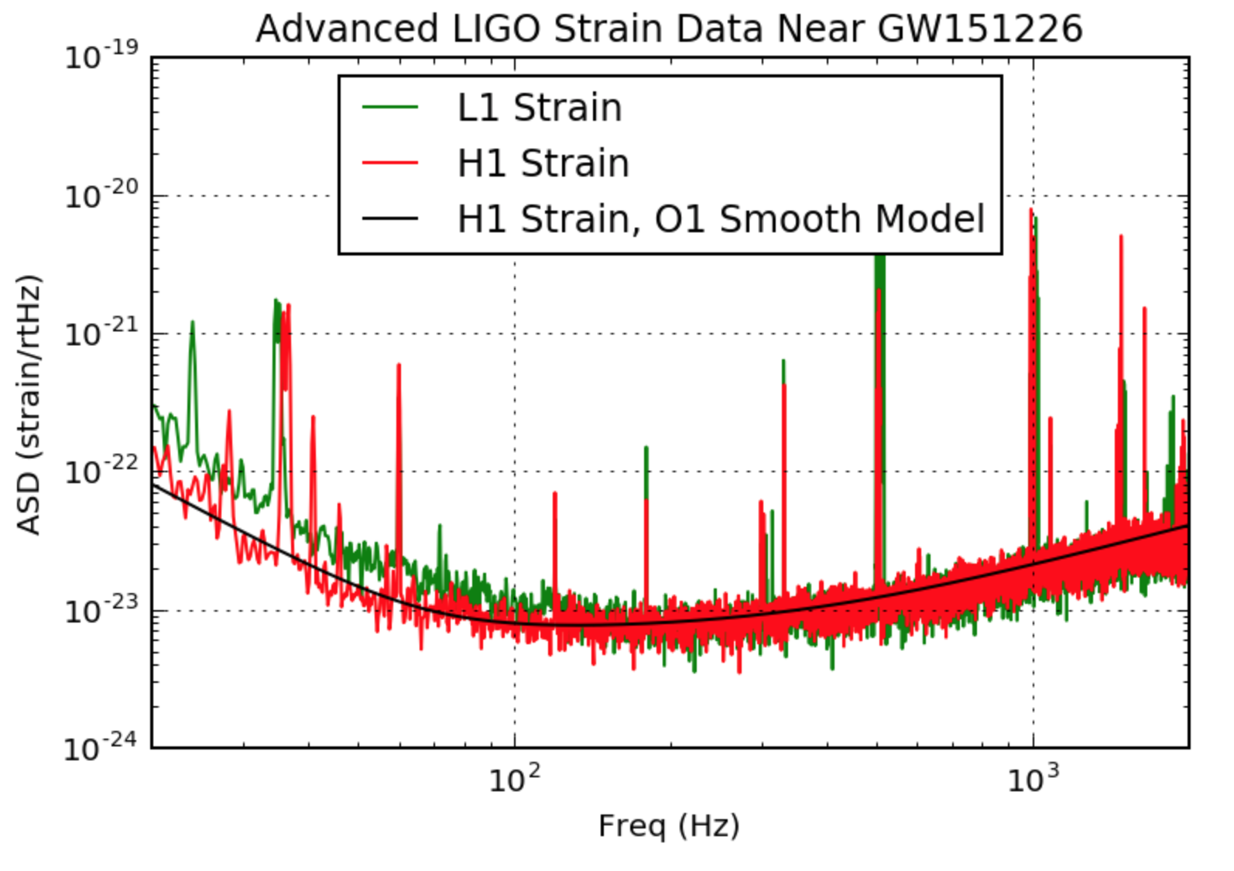

Figure 2: Advanced Strain Data vs Time

Next, we need to compile all this data in a form that we can work with and match it with the waveform template we will later generate. To take a look at the frequency content of the data, we plot the data in the Fourier domain. To do that we plot the ASD (Amplitude Spectral Density) which is an estimate of the "strain-equivalent noise" of the detectors and has units of strain/rt(Hz), versus the frequency. This plays a large factor in the detector’s sensitivity and ability to recognize gravitational wave signals. The ASD can be calculated as the square root of PSD (Power Spectral Density) which is the averages of the square of fast Fourier transforms. The frequency domain here is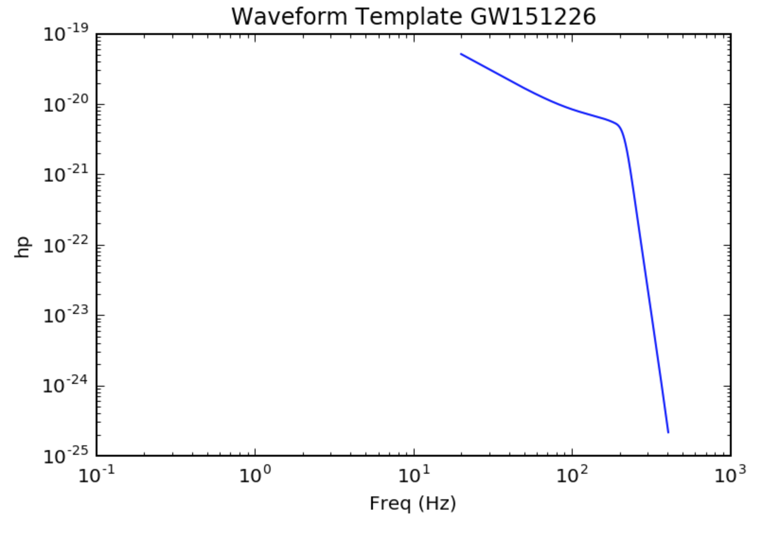 between 0 and 2048 Hz but we only use the data above 20 Hz. This is because below 20 Hz the data would not be properly calibrated and noise would dominate. Since the sampling rate here is 4096 Hz, anything above the Nyquist frequency of 2048 Hz would not be represented in the data.

Figure 3: ASD Data vs Frequency - GW151226

Next, we proceed to generate the waveform templates. The user selects the mass of BHs of the system, the system’s spin and sampling rate. For accurate data, the total mass of the system should be above 20 M☉ and the sampling rate should match that of the PSD. We plot the waveform as h+, the size or amplitude of the wave, as a function of the frequency.

Figure 5: Waveform Template for total mass of 100 M☉

Now that everything is set up and ready to go, we get to the main show. To go on calculating the detection range of BBH mergers, we use the h+ values and the PSD to calculate the horizon distance and we loop over both detectors. The calculation for the horizon distance is described in equations 3-5 in <https://arxiv.org/abs/1203.2674>. To compute the detection range we need to average the horizon distance over source and orientation. This is done by setting the average amplitude to be 1./2.2648 times the maximum value that we calculated.

To get an idea of how the detection range might look over a range of masses, we loop the process over a range of total masses between 20 and 1200 M☉ with an incremental of 1 M☉ and plot the results. The results show a poisson-like distribution with a peak between 300 and 500 M☉ depending on the detector and event chosen as shown below. Beyond the peak, the detection range begins to decrease as a function of the total mass of the system in a negative exponential like manner. This can be explained as systems of higher mass giving out stronger gravitational waves and so having higher detection ranges. But when the masses of the BBH mergers become too heavy beyond 500 M☉, their spin and orbits are usually very weak so the gravitational waves they produce become more frail and harder to detect with increasing mass.

To conclude, through this notebook we are able to use the event data provided by the LOSC and generate waveform templates, which we match together and use to calculate the detection range of BBH mergers. Plotting them over a range of masses, we are able to see that they follow a poisson-like distribution and beyond the peak, the BBH merger’s gravitational waves become weaker and weaker resulting in the detection ranges starting to decrease exponentially.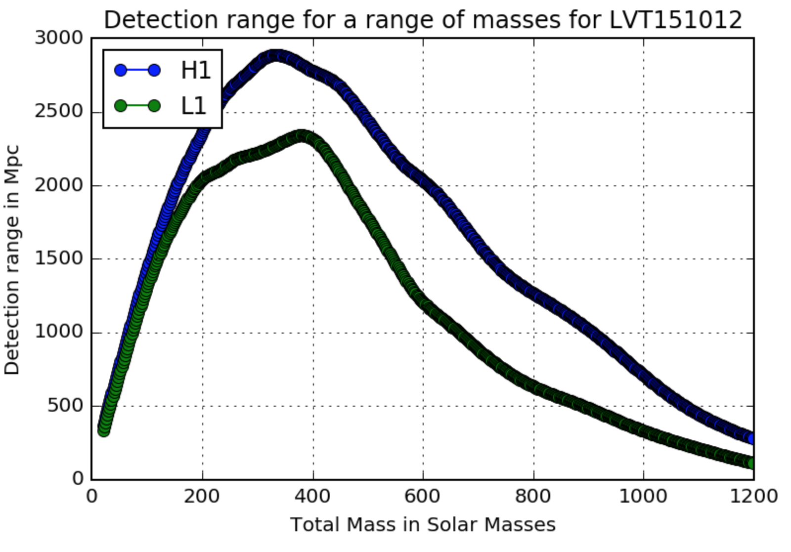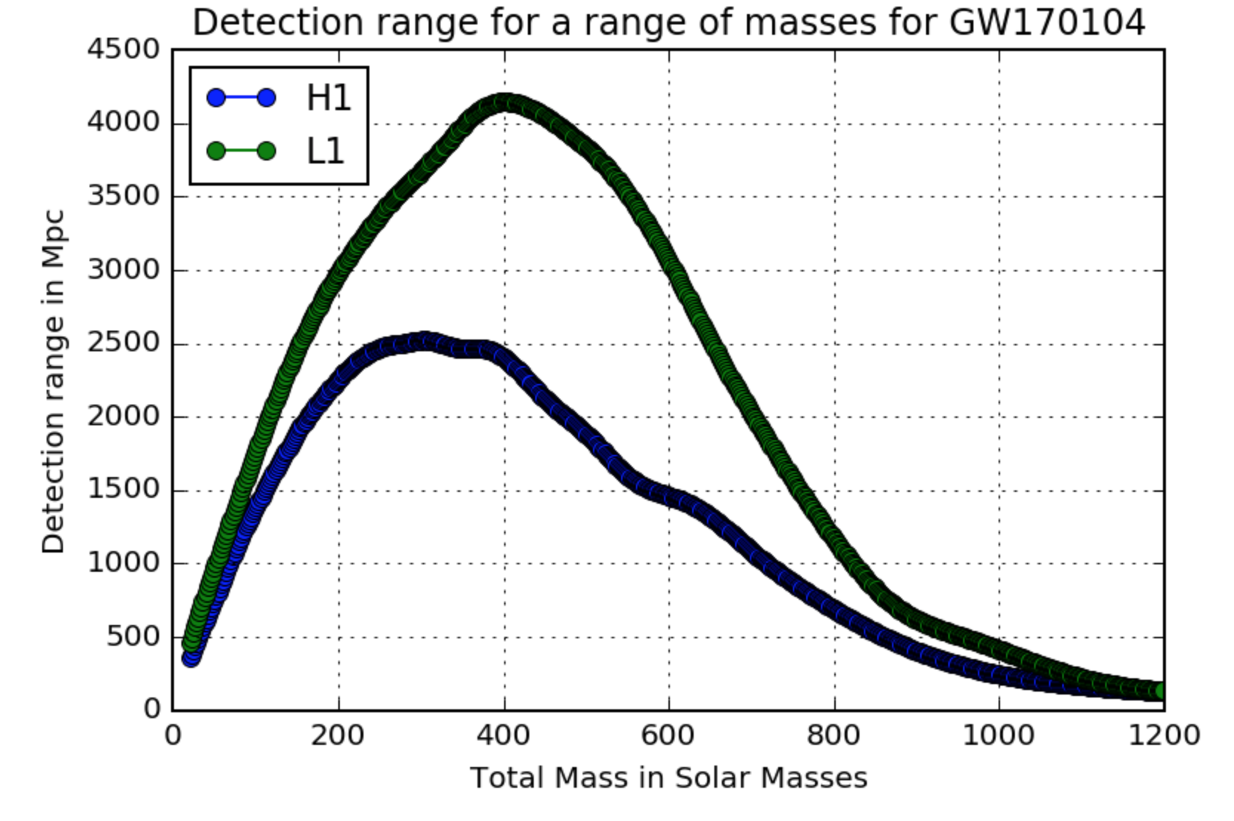

Figure 6: Detection Range vs Total Mass for LVT151012

Figure 7: Detection Range vs Total Mass for GW170104

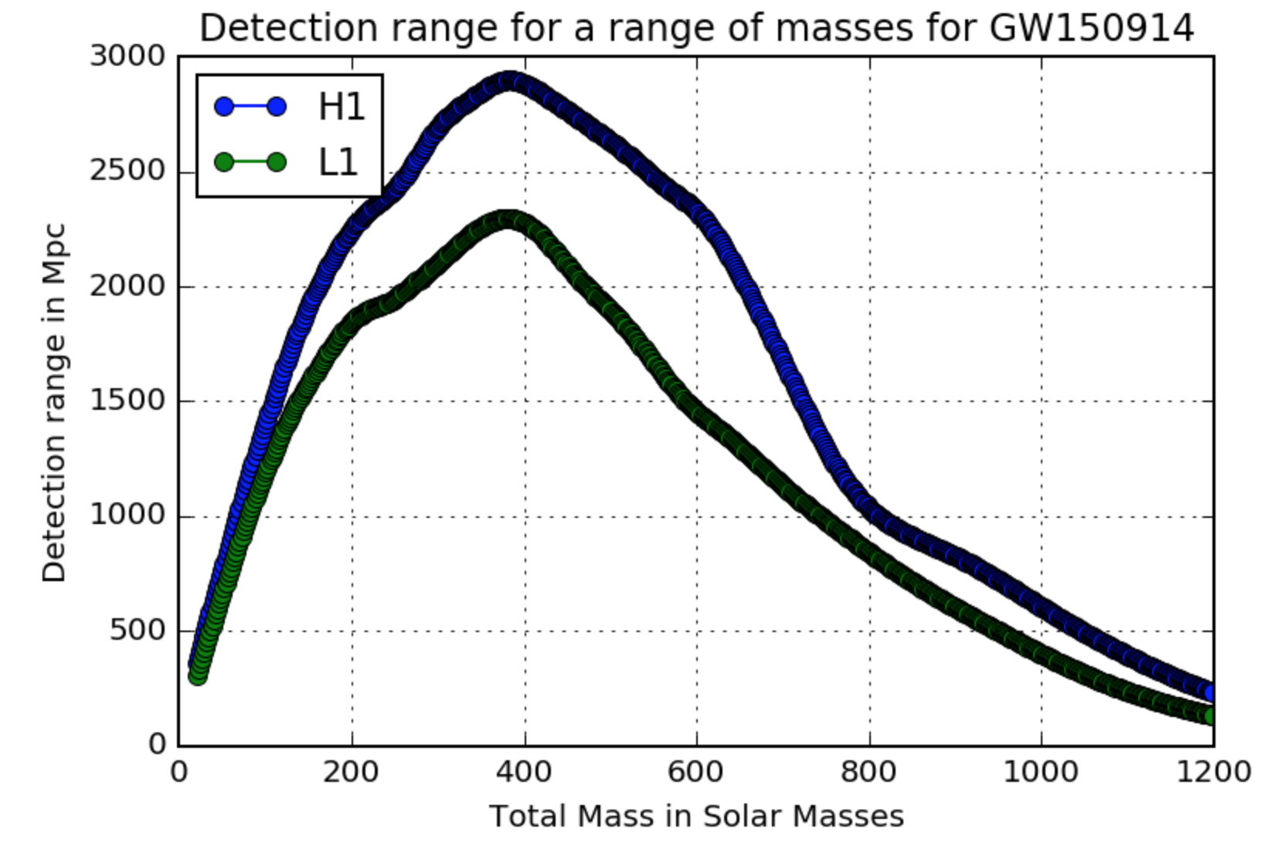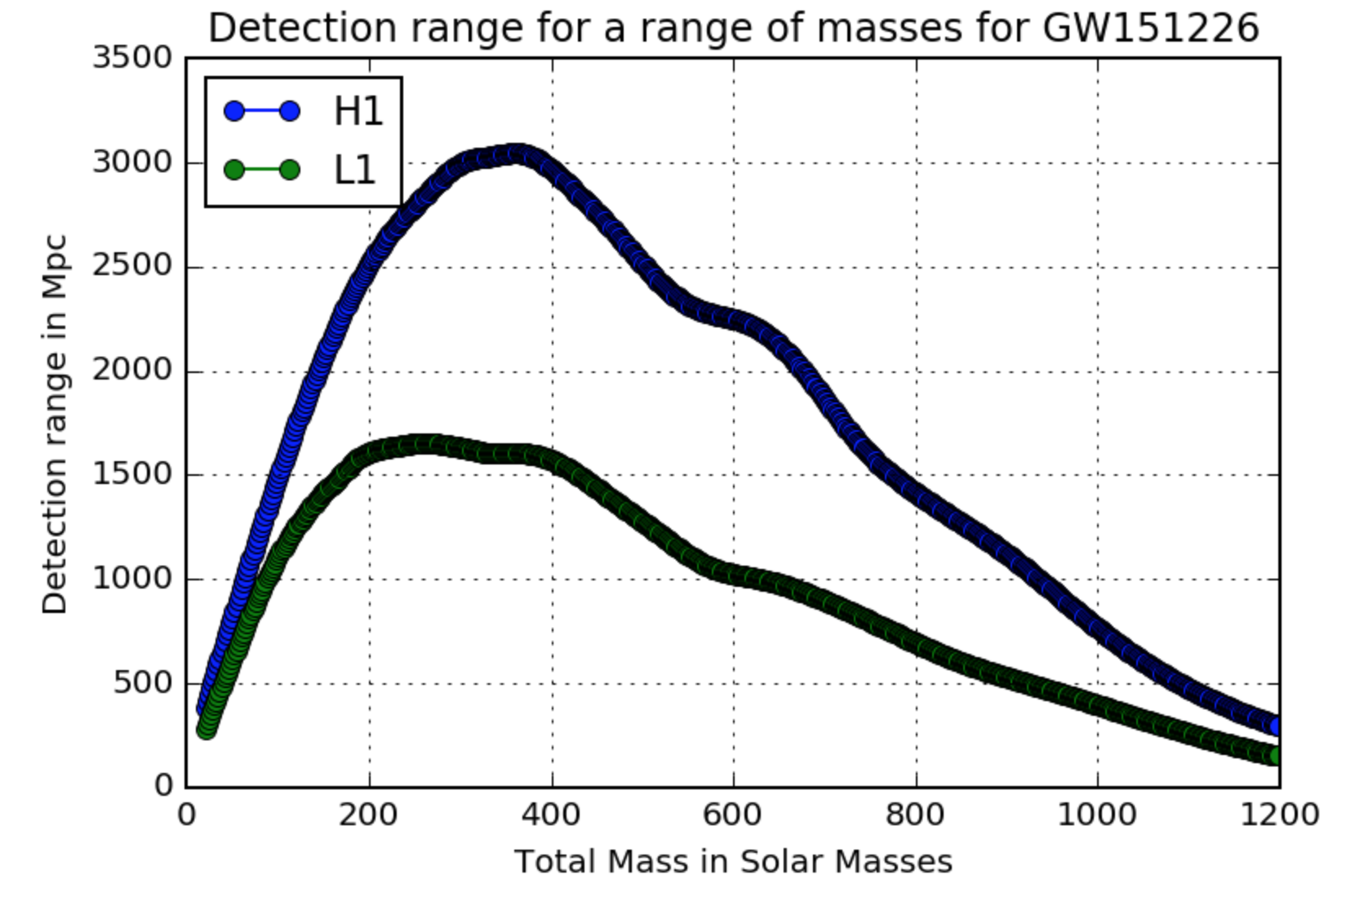

Figure 9: Detection Range vs Total Mass for GW151226

Figure 8: Detection Range vs Total Mass for GW150914

Notebook: <https://notebooks.azure.com/BasselHeiba/libraries/LIGOProjectBH> ——BBH DR General Code.ipynb

References:

M Vallisneri et al. "The LIGO Open Science Center", proceedings of the 10th LISA Symposium, University of Florida, Gainesville, May 18-23, 2014; also [arxiv:1410.4839](http://arxiv.org/abs/1410.4839)

https://github.com/ligo-cbc/binder/blob/master/Make_waveform.ipynb

https://notebooks.azure.com/nitz/libraries/pycbc

https://dcc.ligo.org/LIGO-T1100338/public

https://arxiv.org/abs/1003.2480

https://arxiv.org/abs/gr-qc/0509116

https://arxiv.org/abs/1203.2674

<https://losc.ligo.org/s/events/GW150914/LOSC_Event_tutorial_GW150914.html>

"This research has made use of data, software and/or web tools obtained from the LIGO Open Science Center (https://losc.ligo.org), a service of LIGO Laboratory and the LIGO Scientific Collaboration. LIGO is funded by the U.S. National Science Foundation."